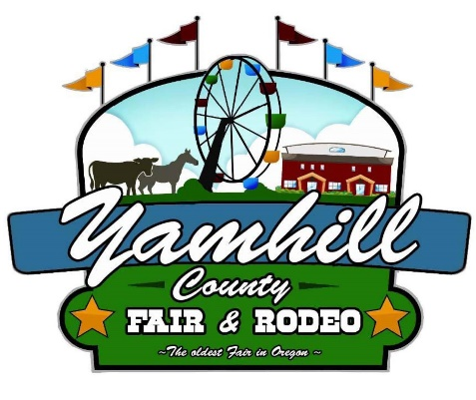
YAMHILL COUNTY FAIR & RODEO
YAMHILL COUNTY FAIR DEMOLITION DERBY COMMITTEE
REGISTRATION ENTRY
I WILL ATTEND THE DRIVERS MEETING PRECEDING THE DERBY. I AGREE TO ACCEPT AND COMPETE UNDER THE RULES PUBLISHED BY THE YAMHILL COUNTY FAIR DEMOLITION DERBY COMMITTEE. I HAVE READ THE RULES AND I AGREE TO ACCEPT THE JUDGES’S RULING AS FINAL IN ALL MATTERS OF INTERPRETATION AND PROTEST.
DRIVERS NAME. ___________________________________________________________________________

ADDRESS. ____________________________________, CITY, STATE, ZIP_________________________

COUNTY. _________________ SOCIAL SECURITY#___________________________________________
Social Security number needed if collecting prize money.
PHONE NUMBER __________________________________________________________
DRIVERS LIC NUMBER. _______________________. STATE ___________________
CLASS. _______________________________________
NOTES.

EVERY DRIVER, CREWS, GUEST MUST SIGN A RELEASE AND WAIVER
EVERYONE UNDER THE AGE OF 18 MUST BE SIGNED BY PARENT OR GUARDIAN

